**Order & Manufacturing**

**Management System**

Project Proposal

­­­

By

**Miss. Nontra Mahachanont 542115026**

**Mr. Parinya Panyanak 542115034**

Department of Software Engineering

College of Arts, Media and Technology

Chiang Mai University

Project Advisor

________________________

**Mr. Phudinan Singkhamfu**

|  |  |  |  |  |  |  |
| --- | --- | --- | --- | --- | --- | --- |
| **Document Name** | **Version** | **Status** | **Date** | **Viewable** | **Reviewer** | **Responsible** |
| **Documents** | | | | | | |
| Order & Manufacturing_Management_System_Proposal_V.0.1.docx | V.0.1  - Add Chapter 1  - Introduction & Background  - Adjust Project Name | Draft | 07-02-2014 | NM, PP, PS | NM, PP | NM, PP |
| Order & Manufacturing_Management_System_Proposal_V.0.2.docx | V.0.2  - Adjust Abstract  - Add Chapter 3  - Quality Standards | Draft | 27-02-2014 | NM, PP, PS | NM, PP | NM, PP |
| Order & Manufacturing_Management_System_Proposal_V.0.5.docx | V.0.5  - Add Chapter 2  - Business Review  - Business Tools  - Software review  - Technology Review  - Development Tool Review  - Add Chapter4  - Project Plan | Draft | 01-03-2014 | NM, PP, PS | NM, PP | NM, PP |
| Order & Manufacturing_Management_System_Proposal_V.0.7.docx | V.0.7  -Add Chapter5  - References  - Adjust Technology Review  - Adjust Schedule & Milestone | Draft | 03-03-2014 | NM, PP, PS | NM, PP | NM, PP |
| Order & Manufacturing_Management_System_Proposal_V.0.9.docx | V.0.9  - Adjust Chapter 1  - Adjust Chapter 2  - Adjust Chapter 4  - Fix inappropriate word | Draft | 04-03-2014 | NM, PP, PS | NM, PP | NM, PP |

**Document History**

**\*NM = Nontra Mahachanont**

**\*PP = Parinya Panyanak**

**\* PS = Phudinan Singkhamfu**

**Abstract**

Nowadays as a Phungnoi bakery manufacture, no have order management system and cannot control ingredients in company. An alternative way to help manufacturer manage their order or to help manufacture can control the ingredients of manufacturing quickly and conveniently. Also, they can get the order from the customer and bring them to calculate the ingredients of manufacturing. A new system should be developed. For this project, "Order & Manufacturing Management System" is created. This system is a web application which consists of basic order management features, member management features, ingredient management features and decision support system for assisting both customers and any administrator of manufacture while they are performing commerce activities. The system will provide customer order to manufacturing; it is allowing the administrator to manage the customer’s order and also to renew-order for over ordering which may distribute product to another brunch. Then the system will calculate the ingredients of manufacturing, which already re-ordered by administrator. Moreover, this system has a report to tell the manufacturer process to usage in their manufacturer. Our system is designed in order to solve the order and manufacturing problems such as materials usage in manufacturing and complicate order management. The Order & Manufacturing Management System is developed on the basis of .NET framework technology.

In this document is including introduction and background, business review, technology review, quality standard, and project plan. In the first part is an introduction and background part will show the problems, tools and benefit of the project. Second, business review is where showed the common feature of the web service needs to have. Third, technology review part presented the tools needed to implement. Fourth, quality standard is the standard used in the project, and lastly project plane is shown how long the web service needs to implement.

**Table of contents**

Document History …………………………………………………………………………….2

Abstract………………………………………………………………………………………..3

Table of Contents……………………………………………………………………………...4

Chapter One | Introduction and Background 5

Chapter Two | Literature Review 6

2.1 Business Review 6

2.2 Business Tools and Software Review 7

2.3 Technology Review 9

2.4 Development Tool Review 13

Chapter Three | Quality Standard 16

3.1 ISO29110 for Very Small Entity (VSE) 16

3.1.1 Project Management process 16

3.1.2 Software Implementation process 16

Chapter Four | Project Plan 17

4.1 Motivation 17

4.2 Aims and Objectives 17

4.3 Deliverables and Limits 18

4.3.1 Deliverables 18

4.3.2 Limits 19

4.4 Schedule & Milestones 19

Chapter Five | References 24

# **Chapter One | Introduction and Background**

# Formerly, there are many problems about manufacture which manage their order. These things can occur in Phungnoi bakery manufacture and affect to another work while they are not obtaining their correctly order. When these situations happen, most of them may try to re-check order to resolve their wrong order list. The popular ways that Phungnoi bakery may use in this situation were increase the number of workers and take a more time to re-check the entire order problems. By these ways, if they aware enough, they may increase the effectiveness of the worker because the accuracy in order is very important since they know that main data are correct, may be some data be lost but not know where is the defect and how they can re-check it become to the right data.

# Nowadays, there are many technologies and tools developed for many purposes. So the manufacturer is cannot handle their ordering data and control their manufacturing may use these technologies to resolve its. The technology that very useful and accuracy obtain an order from the customer and calculate all ingredients of manufacturing. With this, they can use information in the system and share it to another worker with the same document. When their workers see this data, they may understand it more and can cooperation work with another role. This solution may be a good way to managing order system, but there is one important problem that happens in manufacturing. The problem is they cannot control their materials anymore after get order list. Because of manufacturer cannot know that how many materials are uses to manufacturing order in each day. So the calculation ingredients will affect to the manufacturing.

# With these problems, our group decides to create Order & Manufacturing Management System to solve all previous problems. By creating as a web application with consists with order management system, member management system, ingredient management system and report system. The main objective of this system is to handle the order data and control the manufacturing part for estimate the ingredients of the manufacturer. We hopefully that this system and all function implemented will solve the manufacture management problem.

# **Chapter Two | Literature Review**

## Business Review

**Overview**

Order & manufacturing management is a web application to manage order that used to produce bakery and calculate ingredient which use in each type of bakery.

**Target**

The main target of order & manufacturing management web application is how we control many orders that using for product bakery and control how many ingredient used in each type of bakery.

**Benefit**

* The customer gets convenient to order the product.
* The customer can know their transaction history.
* The company can really know how many products should be manufacturing.
* The company can know their transaction history.
* The company can know their manufacturing history.
* The company can control the usage of ingredients.
* The company can produce accuracy product for each customer order.

## Business Tools and Software Review

## Phungnoi Bakery website

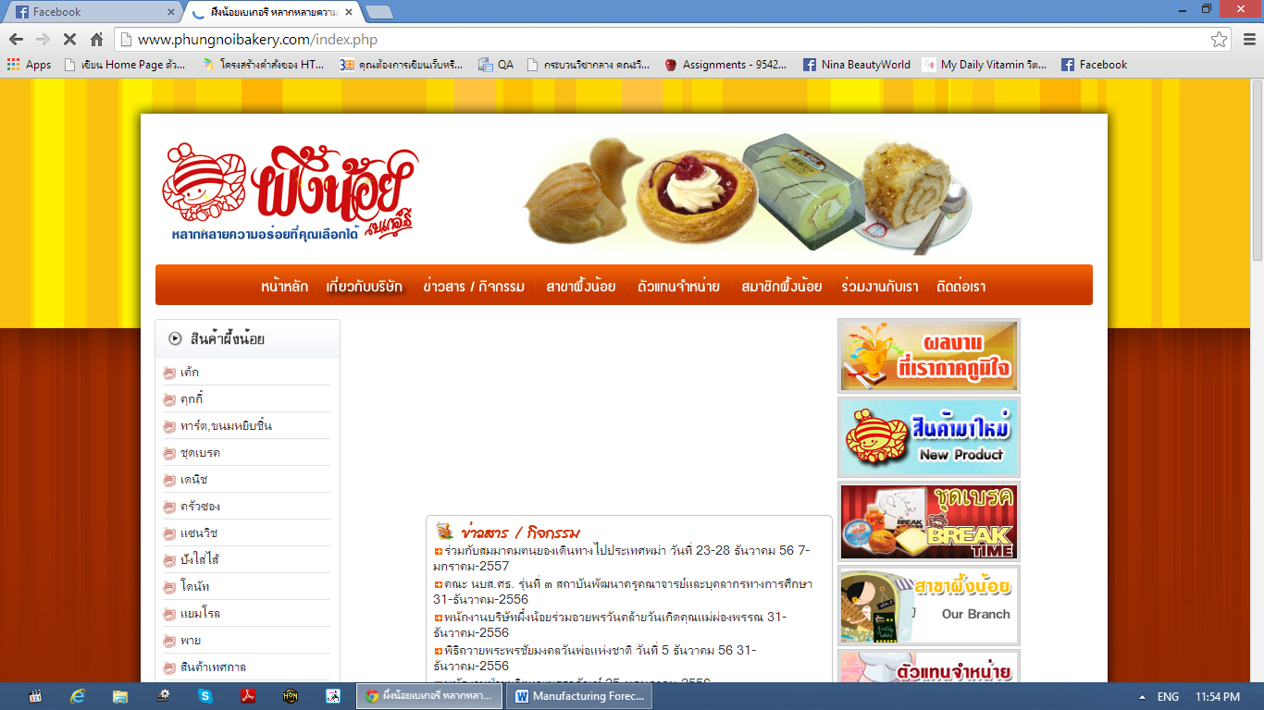

**Figure 2.1 Phungnoi Bakery website Review**

## Software Description

This website is Phungnoi Bakery website. The Phungnoi bakery company using for advertise their bakery thought this website. We can see many products from this site. Some part of website will provide a news or activity of the company.

**Pros**

* Provide many detail of product.
* Have news and activity is shared from company.

## Cons

* + Not support ordering from customer.

- Not support member system.

## Bakery land website

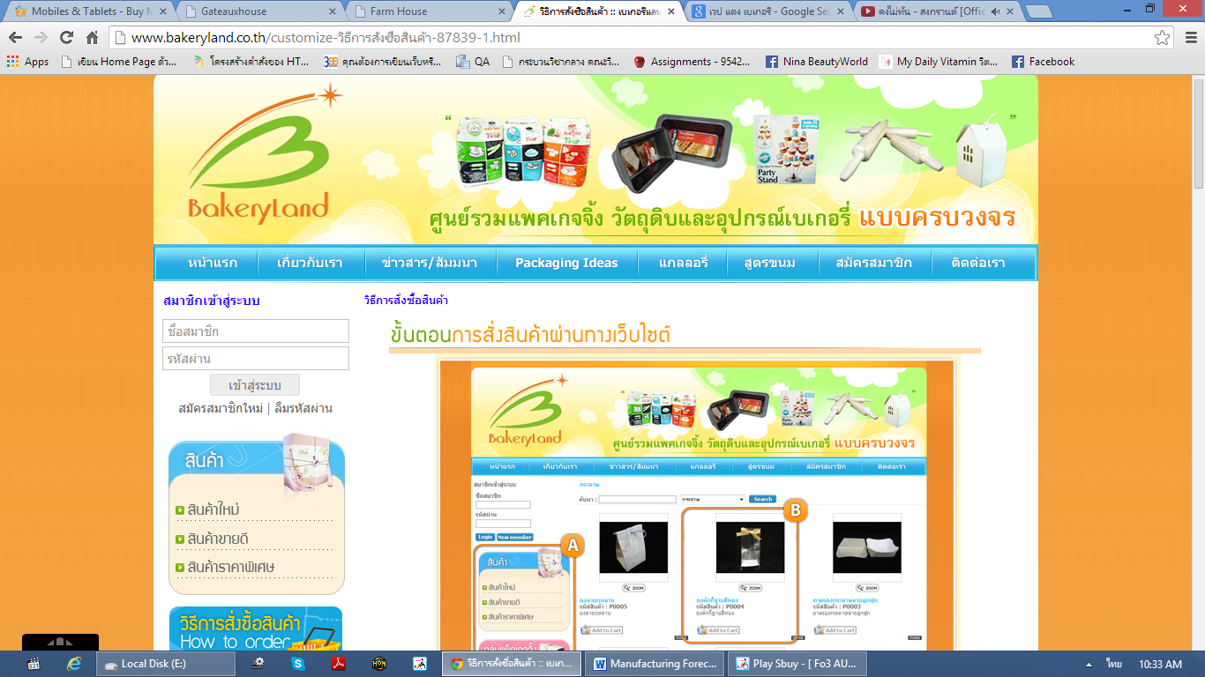

**Figure 2.2 Bakery land website Review**

## Software Description

This website is a website of Bakery land using for trading. It has many type of product included package and bakery material.

## Pros

* Have order system to order product.
* Have tutorial for ordering
* Good category management.

## Cons

* Can not

## PRIMS software

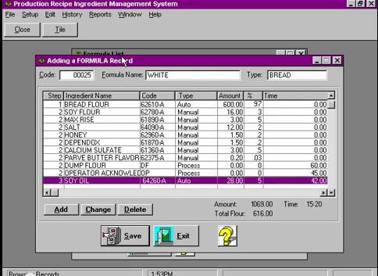

**Figure 2.2 PRIMS software Review**

## Software Description

This program is the ingredient management program in the enterprise.

## Pros

**Cons**

## Technology Review

## Spring Framework



**Figure 2.3 Spring Framework Review**

## Technology Detail

The spring framework is an open source tool for supporting Java-based enterprise application development. This framework use to develop any java application and make J2EE easy to use. It contains pattern and configuration for programming which can be deployed on any platform. It also supports various components to work together such as JDBC and Hibernate.

## Alternative Technology

* ASP.NET Framework

## The selection of this technology

* Support MVC pattern.
* Support .Net and java.
* Easy for unit testing when split it to another part with JUnit.
* Support to connect with various components and technologies.

## Cascading Style Sheets (CSS)

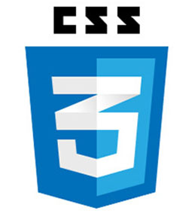

**Figure 2.4 CSS Review**

## Technology Detail

CSS is stands for Cascading Style Sheets. It is a last version of CSS style sheets used to design element of website such as layout, color, size or font of website. Then display HTML elements that presentation of web pages.

## The selection of this technology

- CSS make web pages look better than only HTML does.

- Helps to design the web flexibility.

- Redesign (i.e. colors, size, fonts) with not has effect to HTML code.

- The feature more than the old version such as Combinatory, CSS Selectors, Pseudo-elements, Style properties.

## HTML5



**Figure 2.5 HTML5 Review**

## Technology Detail

HTML5 is the lasts revision of the HTML. It is a markup language to create a user interface for present contents that can be displayed in a web browser.

## Alternative Technology

* Another HTML version
* XHTML

## The selection of this technology

- Makes creating accessible sites easier.

**-** Allow other can access easily.

**-** Simple and clean.

**-** Easy to handle error.

**-** Reduce the external plug-in such as flash.

**-** Support for local storage.

**-** New content-specific elements, like <article>, <footer> and <header>.

**-** New form controls, like calendar, date, time, email and URL.

## Development Tool Review

## NetBeans



**Figure 2.6 NetBeans Review**

## Development Tool Description

NetBeans is an open-source program to integrated development environment for developing with any language such as Java, PHP, C++ and other programming language. It is referred to developing Java desktop applications and also develops web application. It's constantly improving Java Editor, provide many features and an extensive range of tools, templates and samples.

## Alternative Tool

* Eclipse
* IntelliJ IDEA

## The selection of this tool

* Open source for any users no need license or contract.
* Provide many features necessary for MVC pattern development.
  + Support Ant and Maven – no custom built system that only works in the IDE.
  + Includes new features for editing/debugging HTML5.
  + Written using swing.
  + Built-in support for version control systems plug-ins. For example, it can be a nightmare to get SVN configured correctly on 64 bit systems.

## MySQL Workbench



**Figure 2.7 MySQL Workbench Review**

## Development Tool Description

MySQL Workbench is an open source relational database management system which used for develop database architects. It can do such as provides data modeling, comprehensive administration tools for server configuration, SQL development, user administration and backup. Then also supports many development tool for create a web application such as Eclipse, NetBeans.

## Alternative Tool

* Microsoft Access
* SQLite
* TomCat
* Appserve

## The selection of this tool

* Easy to integrate with many development tool.
* Provide many features support.
* More security.
* Flexible for using and manage via other tool.
* Can visualize table relationships.

## Adobe Dreamweaver



**Figure 2.8 Adobe Dreamweaver Review**

## Development Tool Description

Adobe Dreamweaver is the tool for design and develop the website that provides a visual interface for making and editing HTML websites.

## Alternative Tool

* Notepad++
* CoffeeCup Free HTML Editor
* PageBreeze
* TextMate

## The selection of this tool

## Complete function that necessary to create website.

* Work with offline.
* Support with layout tool.
* Can split the code and design of the webpage at the same time.

# **Chapter Three | Quality Standard**

## 3.1 ISO29110 for Very Small Entity (VSE)

ISO29110 is a guide applies to a Very Small Entity (VSE), enterprise, organisation, department or project up to 25 people, dedicated to software development. The Guide provides Project Management and Software Implementation processes which integrate practices based on the selection of ISO/IEC 12207- Systems and Software Engineering —Software Life Cycle Processes and ISO/IEC 15289 Software Engineering – Software Life Cycle Process – guidelines for the content of software life cycle process information products (documentation) standards elements.

### Project Management Process

The purpose of the Project Management Process is to improve the success rate of projects in all areas of knowledge, which allows complying with the project’s objectives in the expected quality, time and cost.

**Activities**

* Project Planning Process
* Project Plan Execution Process
* Project Assessment and Control Process
* Project Closer Process

### Software Implementation Process

The purpose of the Software Implementation process is the systematic performance of the analysis, design, construction, integration and tests activities for new or modified software products according to the specified requirements.

**Activities**

* Software Implementation Initiation Process
* Software Requirements Analysis Process
* Software Architectural Design Process
* Software Construction Process
* Software Integration and Test Process
* Software Delivery Process

# **Chapter Four | Project Plan**

## Motivation

Nowadays, Phungnoi bakery manufacturer has complicated their order data in every day. Sometime can manage their data, and some are cannot. Then there are affect to manufacturing part to control ingredients of all order. By the way, as the technology is growing every day, some company turn it as an advantage by use the system to help them solve the problem by managing data in their company.

So we realized that using normal order management system to solve the problem for manage the order data is easy and faster way to solve the problem, but the disadvantages about this way are each order data cannot be analyze their summary to apply with manufacturing department of the company and cannot be an estimate the ingredients to limit their materials. We are unable to manage it anymore even if the manufacturer are collect the entire order data from the program to analyze and estimate to resolve their over ingredients in manufacturing by themselves, the estimating still continues because the manufacturer not knows about real ingredient usage of the manufacturing compare with order list, they just continue to estimating it in every day but almost over and unstable.

With these reasons, we think there must be some system to manage the problems that can help the manufacturer who needs to know their accuracy data in manufacturing every day. This system should still able to use the report for limiting their cost that can be controlled and has more function to help solve these problems more easily, thereby resulting in “Order & Manufacturing Management System”.

## Aims

The aim of this project is to develop a website that provides member management, order management, ingredients management, and report to manufacturer, also to be a commerce website that makes an order with the manufacturer as quick and easy as possible. And also increasing the effectivenessof the manufacturer will control their standard and the strictness of the manufacturing will limit their budget.

## Objectives

* Alternative way to help manufacturing estimate ingredients and summary all usage.
* Provide multiple systems to help manufacturer can correctly cooperation.
* Activities of the manufacturer are a summary into the report for easy to controlled.
* Alternative way to help customer can order conveniently.

## System Architecture

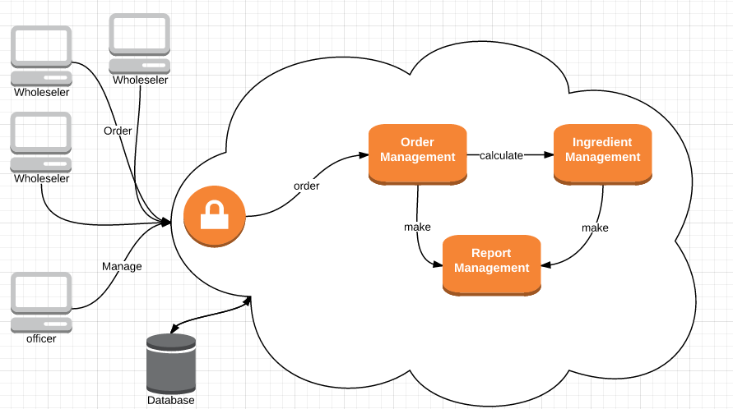

Figure 4: Order & Manufacturing Management System

Figure 4 shows the overview of the Order & Manufacturing Management System. The system controls each department system to manage and report the summary data. Every process, summary information of the report may help the manufacturer can know the value of order and ingredients usage in each day. It will store all activities (amount of purchase order, manufacturing list) to the database system and display summary information on the website. Order & Manufacturing Management System also supported automatically to customer order online. The website has administrator to control system and manage customer authentication. Administrator and the customer can view their history of their own data to inform other management.

## Deliverables and Limits

### Deliverables

**4.3.1.1 Software system**

* Feature#1 Wholesaling online System
  + - * Create website for wholesaler order the product to phungnoi bakery.
* Feature#2 Member Management System
  + - * Create database to control the user in website.
* Feature#3 Order Management System
  + - * Create database to control order of wholesaler in website
      * Create function to control manufacturing order.
* Feature#4 Summary Report System
* Create website to manage report.
* Feature#5 Ingredient management System
  + - Crete database provide detail of ingredient of each product
    - Create function to calculate real quantity of product

**4.3.1.2 Software document**

* Project proposal
* Project plan
* System requirement specification
* Software design document
* Use case
* Use case description
* Class diagram
* Sequence diagram
* Activity diagram
* Testing document
* Test plan
* User acceptance test
* Integration test
* Unit test
* Test record
* Traceability matrix

### Limits

* Membership is required for using all function in the application.
* The application requires Internet connection to execute.
* This application support only fresh bakery manufacturer as a sample for developing and testing the system.
* Forecasting function shall forecast only ingredients.
* Only wholesale can use the order system.

**4.3.3 Future work**

- Product inventory management

## Schedule & Milestones

**Schedule plan:**

Proposal phase: Create proposal document.

Progress I: Create software document of process#1, 2. Then Start creates feature# 1, 2of system.

Progress II: Create software document of process#3, 4. Then Start creates feature# 3, 4of system.

Progress III (Show Pro): Create software document of process#5. Then Start creates feature#5 of system. Overall of the system should be complete or nearly.

Final progress: Integrate and review all document. Make sure all system and document are complete.

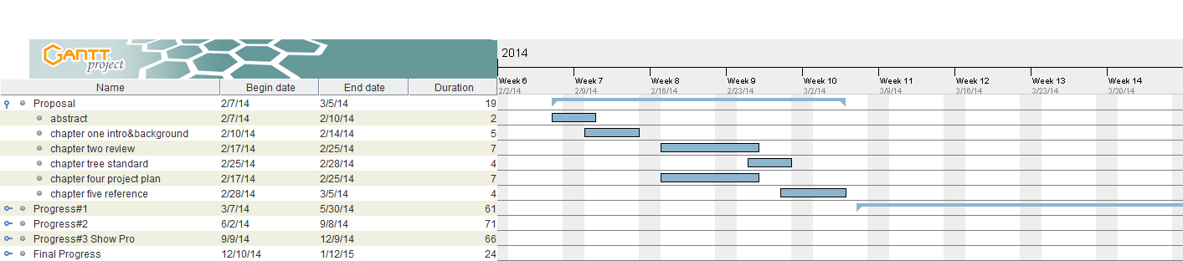

**Figure 4.1: Proposal Milestone**

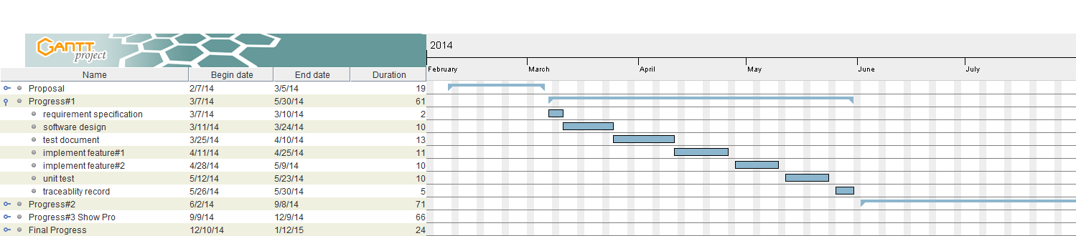

**Figure 4.2: Progress Report I Milestone**

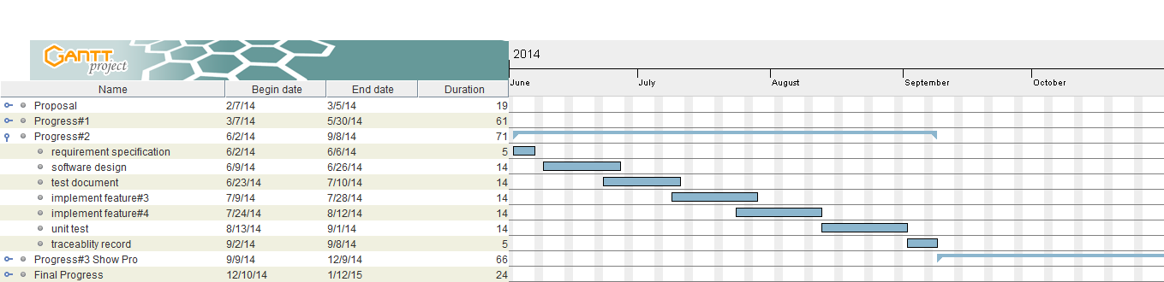

**Figure 4.3: Progress Report II Milestone**

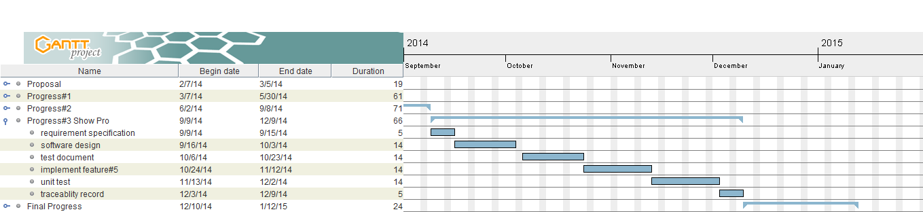

**Figure 4.4: Progress Report Show Pro Milestone**

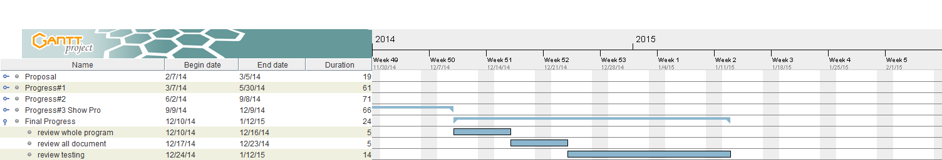

**Figure 4.5: Final Progress Report Milestone**

# **Chapter Five | References**

[1] Adobe Dreamweaver CS6. Available from <http://www.adobe.com/products/dreamweaver.html>

[2] CSS. Available from <http://en.wikipedia.org/wiki/Cascading_Style_Sheets>

[3] VSE. Available from http://profs.etsmtl.ca/claporte/English/VSE/Deploy-Pack/Entry

[4] Project Management Process. Available from http://en.wikipedia.org/wiki/Project_

Management_Professional

[5] Software Implementation Process. Available from http://profs.etsmtl.ca/claporte/

English/VSE/Deploy-Pack/Entry%20Profile-DP-Software

[6] HTML. Available from <http://en.wikipedia.org/wiki/HTML>

[7] PDP Inventory Control Program. Available from http://www.pdpware.com/?cat=7

[8] Absolute |Solutions|. Available from https://www.absolute.co.th/index.html

[9] CD Organizer. Available from http://www.cd-organizer.com/

[10] Netbeans. Available from http://www.softpicks.com/software/Development/

Miscellaneous/NetBeans-IDE-180921.htm

[11] Spring Framework. Available from http://www.oreillynet.com/cs/user/query/q/286%3Fid_

[12] CSS. Available from http://www.oracle.com/technetwork/issue-archive/book-beat-archive-1878886.html

[13] MySQL Workbench. Available from http://www.oracle.com/technetwork/issue-archive/book-beat-archive-1878886.html